ECON 6511: Advanced Applied Econometrics Homework 1 Solutions

1. (Wooldridge, C2) Use the data in BARIUM.DTA for this exercise.

* (a)  Add a linear time trend (t) to equation:  log(chnimp) =β0 + β1 log(chempi) + β2 log(gas) + β3 log(rtwex) + β4befile6 + β5affile6 + β6afdec6  Are any variables, other than the trend, statistically significant?
* 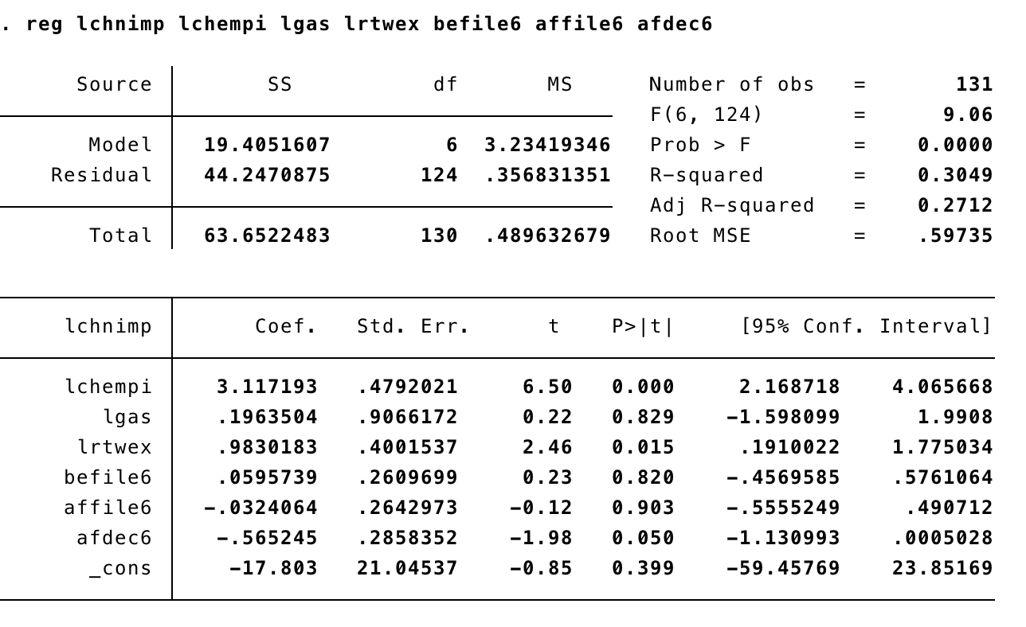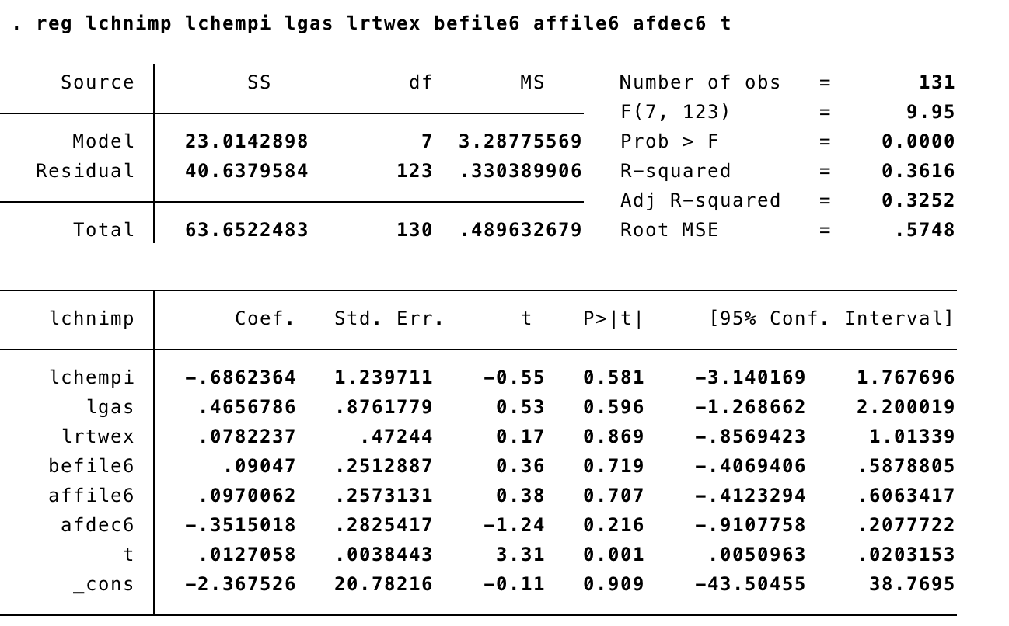

Answer:

The estimated equation is:  log(chnimp) = − 2.37 − 0.686log(chempi) + 0.466log(gas) + 0.078log(rtwex) + 0.090bef ile6 + 0.097af f ile6 − 0.351af dec6 + 0.013t  Only the trend is statistically significant. In fact, in addition to the time trend, which has a t statistic of 3.31, only afdec6 has a t statistic bigger than one in absolute value (| − 1.24|), which is still far below the usual threshold of 2. Accounting for a linear trend has important effects on the estimates

(b)  In the equation estimated above, test for the joint significance of all variables­ except the  time trend. Compute this by hand. What do you conclude?

 Answer:

**F0 = (SSRr − SSRur)/q**

**SSRur/(n − (k + 1))**

where SSRr stands for the sum of the squared residuals of the restricted model and SSRur is the same for the unrestricted model. We also have that n is the number of observations, k is the number of independent variables in the unrestricted model and q is the number of restrictions (or the number of coefficients being jointly tested)

The F statistic for joint significance of all variables except the trend and  intercept, of course) is F = (41.708917−40.6379584)/6 = .54. , p-vlaue = 0.78

The df in the F distribution 40.6379584/123  are 6 and 123. The critical value is approximately 2.18, and so the explanatory variables other than the time trend are jointly very insignificant. We would have to conclude that once a positive linear trend is allowed for, nothing else helps to explain log(chnimp).

(c)  Add monthly dummy variables (January is the excluded month) to this equation and  test for seasonality. Does including the monthly dummies change any other estimates or  their standard errors in important ways? Answer:

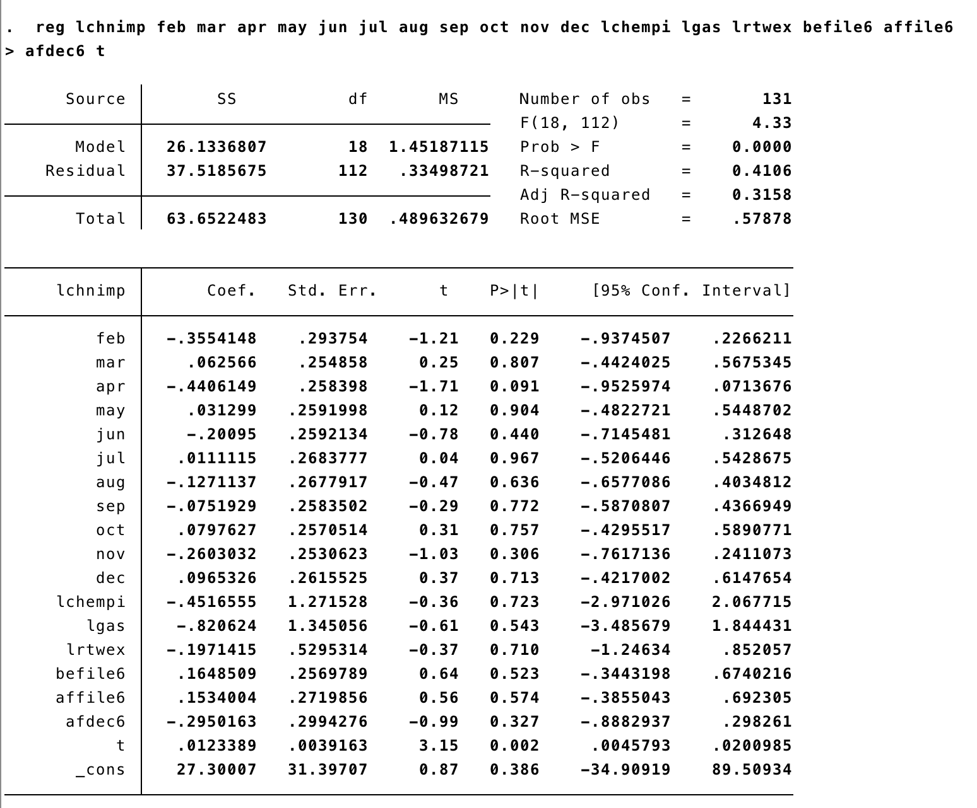

The F statistic for the test of joint significance of the monthly dummies is  F = (40.6379584−37.5185675)/11 = 0.85, which is low indicating that there is no evidence of 37.5185675/112  seasonality. P-value = 0.5943

Nothing of importance changes. The time trend is still very significant and none of the main variables are statistically significant.

2. C5- Use the data in EZANDERS.DTA for this exercise. The data are on monthly unemployment claims in Anderson Township in Indiana, from January 1980 through November 1988. In 1984, an enterprise zone (EZ) was located in Anderson (as well as other cities in Indiana).

1. Regress log(uclmns) on a linear (annual) time trend and 11 monthly dummy variables (exclude January). What was the overall trend in unemployment claims over this pe- riod? (Interpret the coefficient on ­the time trend.) Is there evidence of seasonality in unemployment claims?

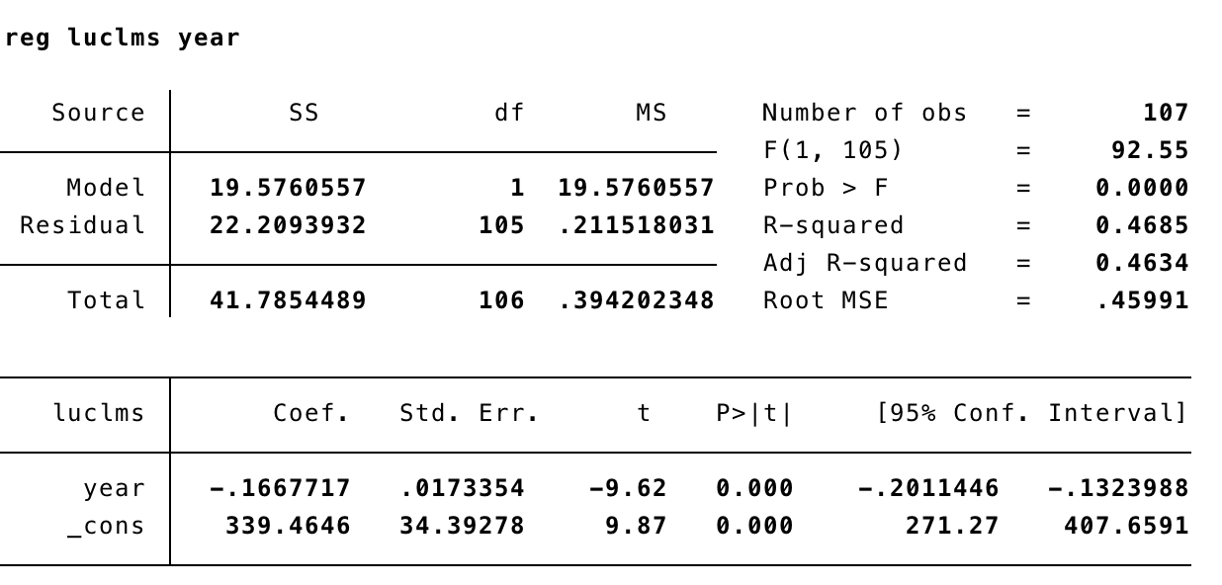

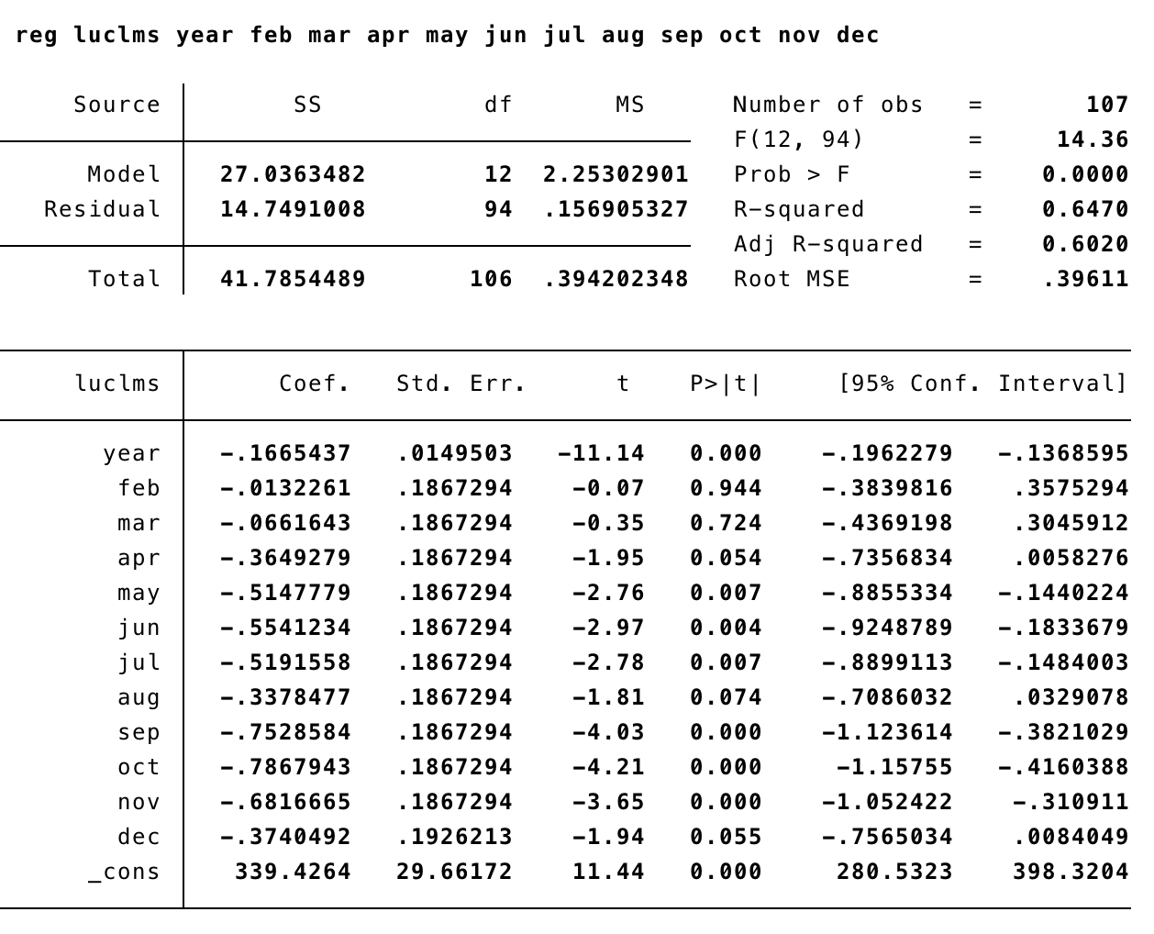

Answer: The coefficient on the time trend in the regression of log(uclms) on a linear  time trend and 11 monthly dummy variables is about -0.1665 (se ≈ .015), which implies  that annual unemployment claims fell by about 16.7% per year on average. The trend  is very significant. There is also very strong seasonality in unemployment claims, with 6  of the 11 monthly dummy variables having absolute t statistics above 2. The F statistic  for joint significance of the 11 monthly dummies is F = (22.2093932−14.7491008)/11 = 4.32 14.7491008/94  with a critical value around 2.

F-value = 4.3224, p-value = 0.00 why significant?

1. Addez,adummyvariableequalto1inthemonthsAndersonhadanEZ,totheregression above. Does having the enterprise zone seem to decrease unemployment claims? By how much?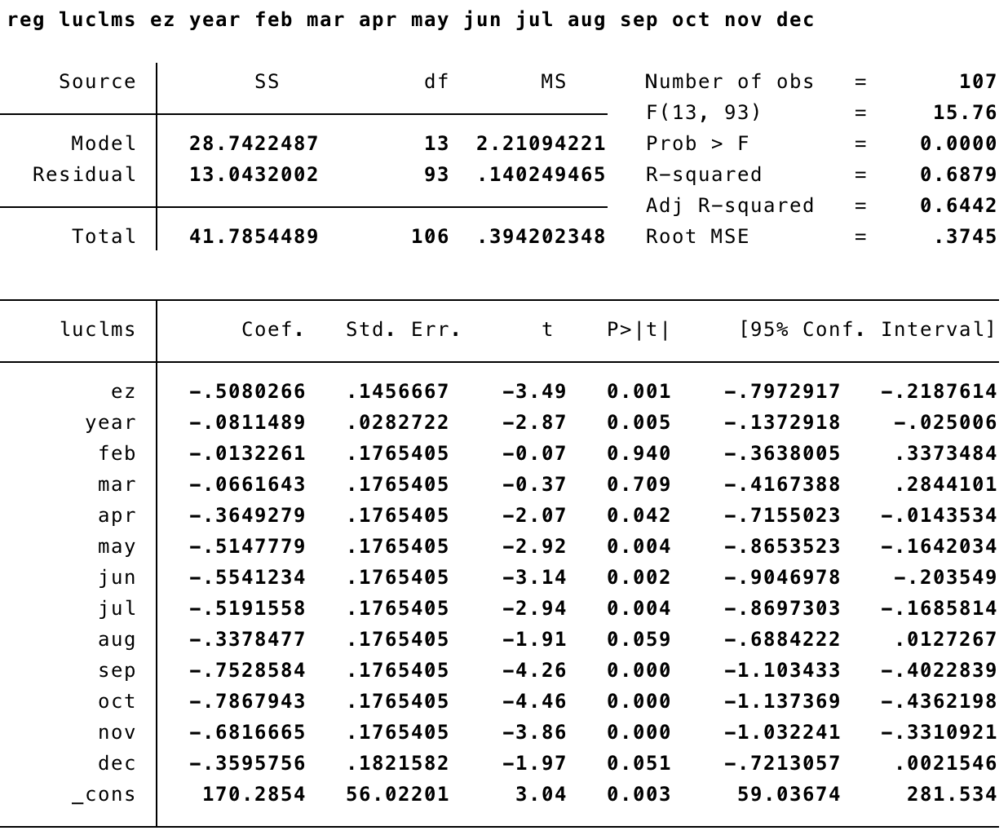

Answer: When ez is added to the regression, its coefficient is about −0.508 (se ≈ .146). Because this estimate is so large in magnitude, we use equation (7.10): unemployment claims are estimated to fall 100 · [1 − e−0.508] ≈ 39.8% after enterprise zone designation.

1. What assumption do you need to make to attribute the effect in part (b) to the creation of an EZ?

Answer: We must assume that around the time of EZ designation there were not other external factors or policies that caused a shift down in the trend of log(uclms), i.e. something else that would cause unemployment claims to drop. We have controlled for a time trend and seasonality, but this may not be enough.

3. (Wooldridge, C10) Consider the model: i3t =β0 +β1inft +β2deft +ut

where i3 is the three-month T-bill rate, inf is the annual inflation rate based on the CPI, and def is the federal budget deficit as a percentage of GDP. Use the data in INTDEF.DTA.

1. Find the correlation between inf and def over this sample period and comment.

Calculate variance inflation factor (should be < 4 for non-collinearity)

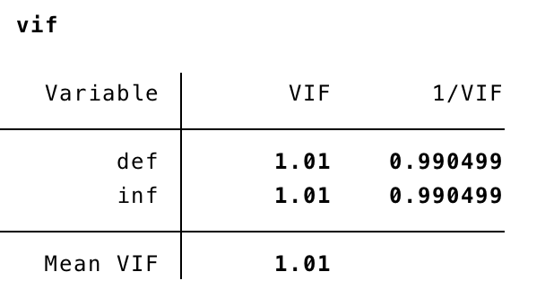vif < 4 so no collinearity

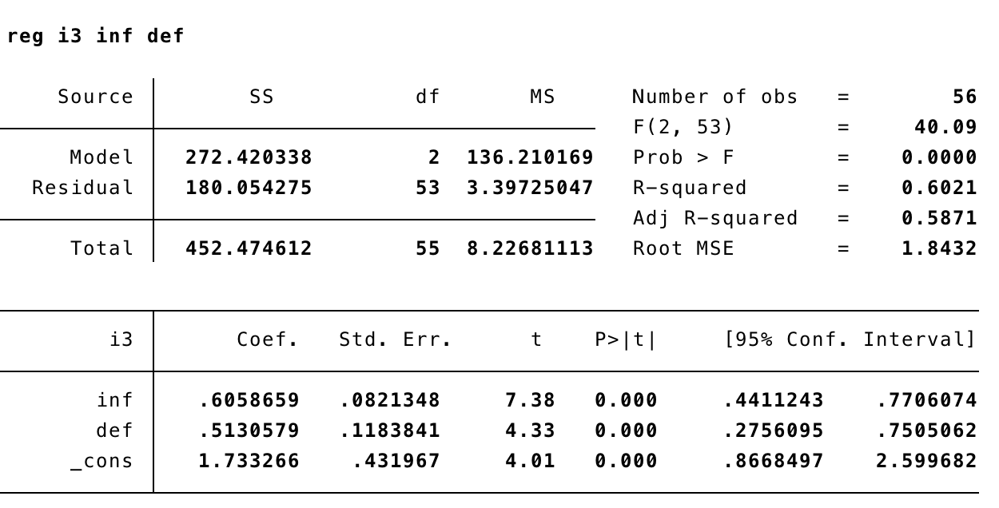

Answer: The sample correlation between inf and def is only about .0928, which is pretty small. Perhaps surprisingly, inflation and the deficit rate are practically uncorrelated over this period. Of course, this is a good thing for estimating the effects of each variable on i3, as it implies almost no multicollinearity.

1. Add a single lag of inf and def to the equation and report the results in equation form.

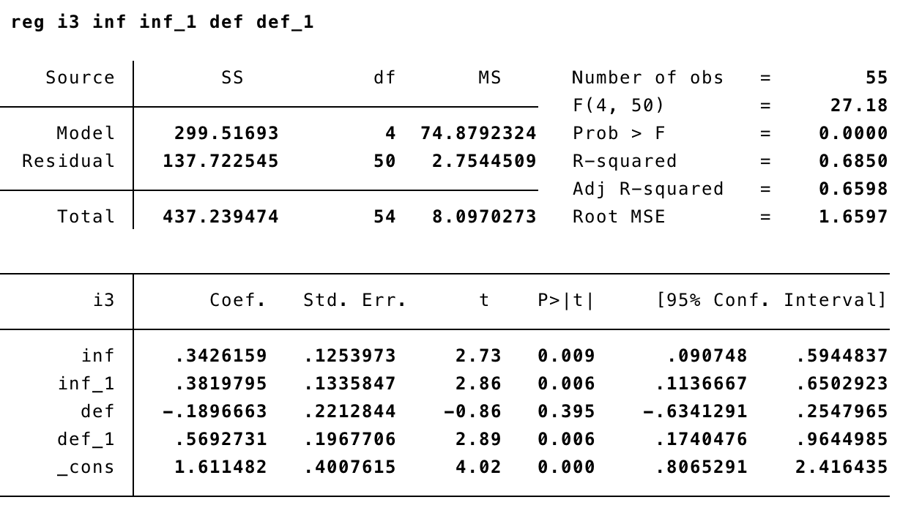

Answer: The estimated equation is:  i3t = 1.61 + 0.343inft + 0.382inft−1 − 0.190deft + 0.569deft−1

1. Compare the estimated LRP for the effect of inflation with that in the original equation without lags. Are they vastly different?

Answer: The estimated LRP of i3 with respect to inf is .343 + .382 = .725, which is somewhat larger than .606, which we obtain from the original model. But the estimates are fairly close considering the size and significance of the coefficient on inft−1.

(d) Are the two lags in the model jointly significant at the 5% level?

Answer:

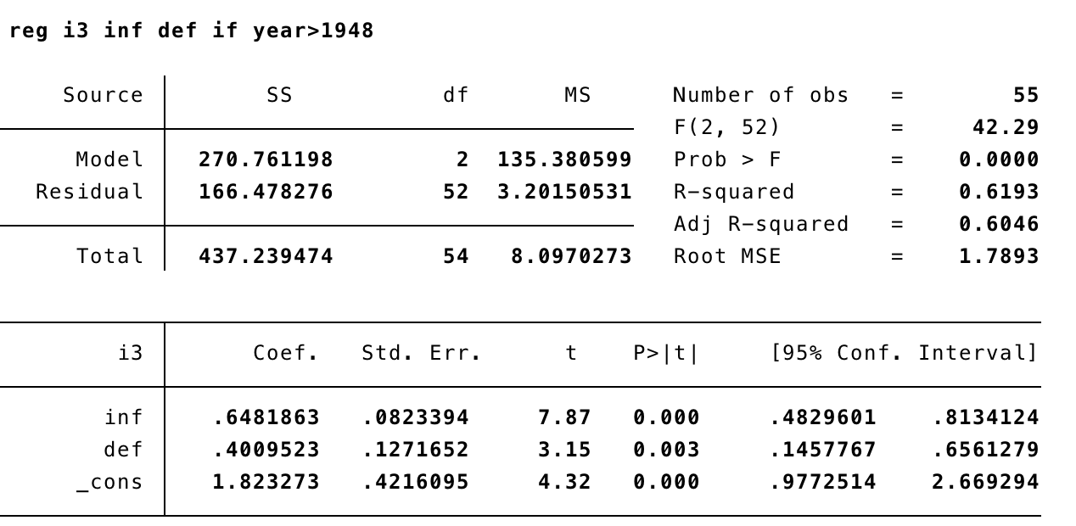

The F statistic for significance of inft−1 and deft−1 is F = (166.478276−137.722545)/2 = 137.722545/50 5.22, with a critical value around 5 for a test at the 1 percent level. So they are jointly significant at the 1% level. It seems that both lags belong in the model. Note: When computing the F statistic, you must drop the first observation from the restricted model to be consistent with the unrestricted model, which does not have this observation since it includes lagged variables.

4. (Wooldridge, C13) Use the data in MINWAGE.DTA for this exercise. In particular, use the employment and wage series for sector 232 (Men’s and Boys’ Furnishings). The variable gwage232 is the monthly growth (change in logs) in the average wage in sector 232, gemp232 is the growth in employment in sector 232, gmwage is the growth in the federal minimum wage, and gcpi is the growth in the (urban) Consumer Prince Index.

(a)  Run the regression gwage232 on gmwage, gcpi. Do the sign and magnitude of βˆgmwage make sense to you? Explain. Is gmwage statistically significant?

Answer:

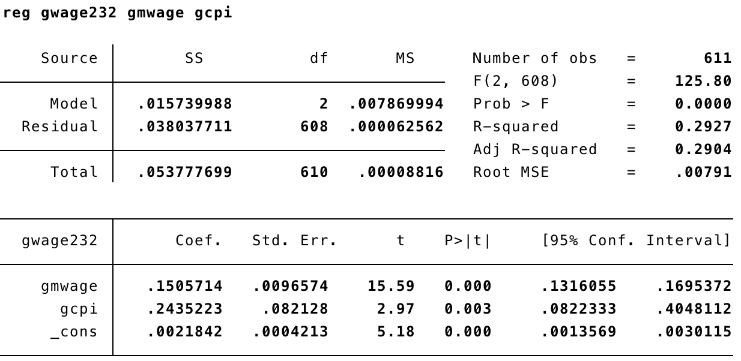

The estimated equation is:  gwage232 = 0.0022 + 0.151gmwage + 0.244gcpi The coefficient on gmwage implies that a one percentage point growth in the minimum  wage is estimated to increase the growth in wage232 by about .151 percentage points.

(b)  Add lags 1 through 12 of gmwage to the equation in part (a). Do you think it is necessary  to include these lags to estimate the long-run effect of minimum wage growth on wage  growth in sector 232? Explain.

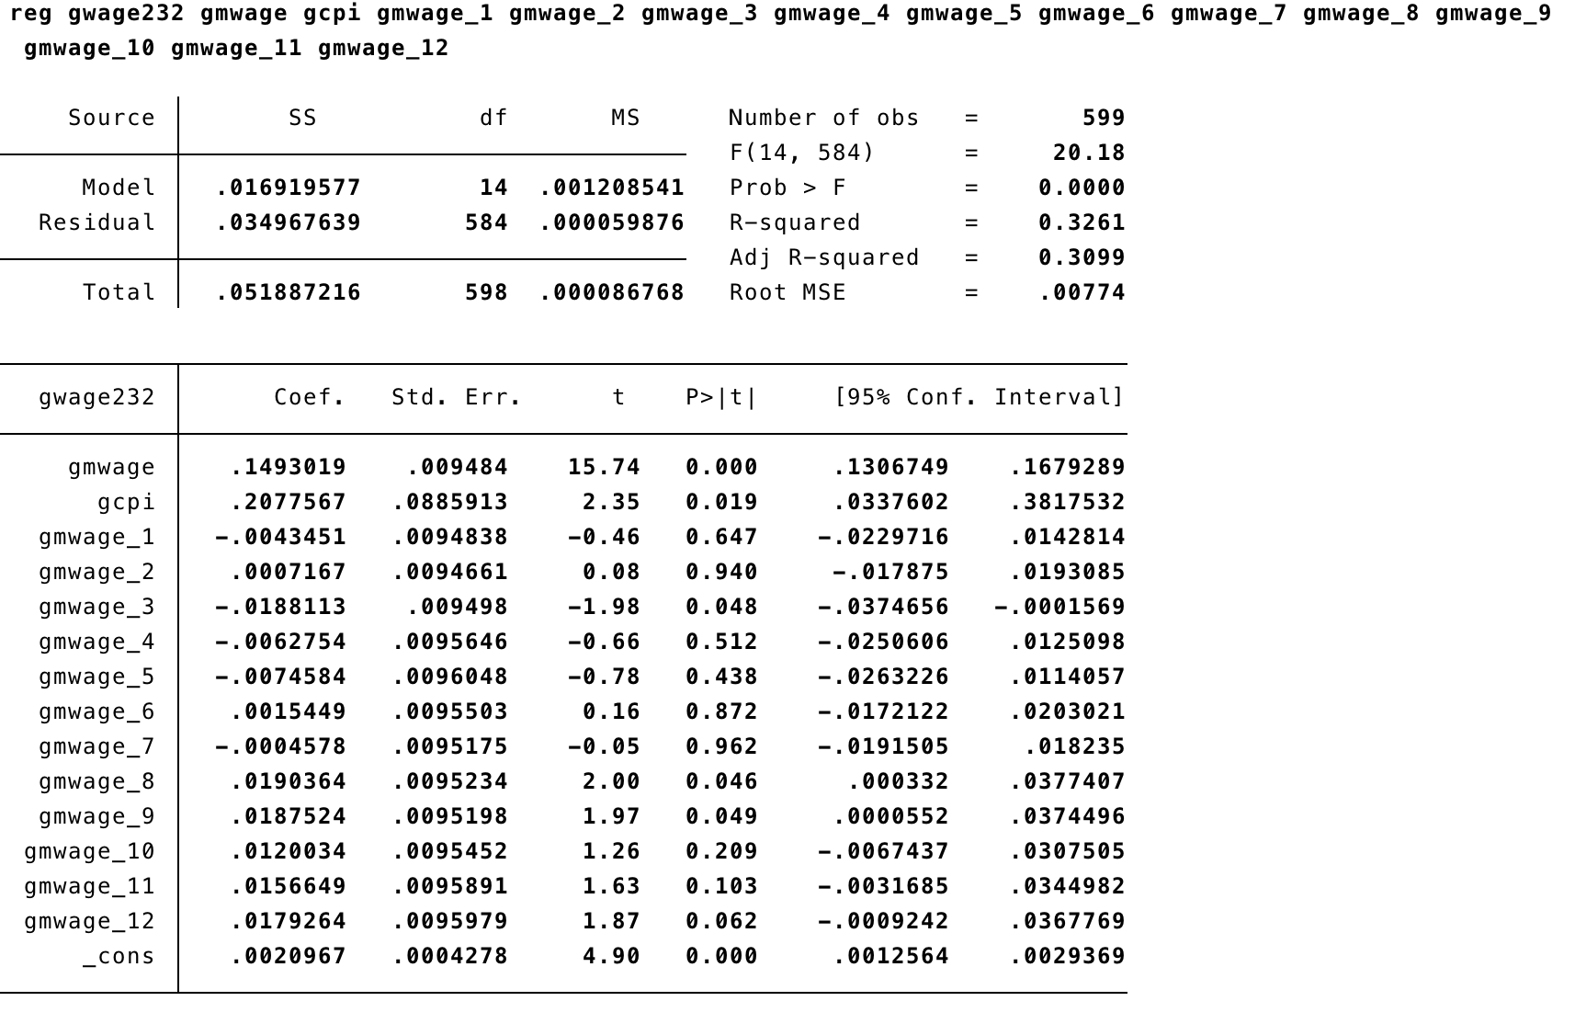

Answer:

When 12 lags of gmwage are added, the sum of all coefficients is about .198,  which is somewhat higher than the .151 obtained from the static regression. Plus, the  F statistic for lags 1 through 12 is F = (.036206155−.034967639)/12 = 1.72 with a critical .034967639/584  value at the 5 percent level of 1.75, which shows they are jointly, marginally statistically 3

significant. (Lags 8 through 12 have fairly large coefficients, and some individual t statistics are significant at the 5% level.) p-value=0.0589

(c) Run the regression gemp232 on gmwage, gcpi. Does minimum wage growth appear to have a contemporaneous effect on gemp232?

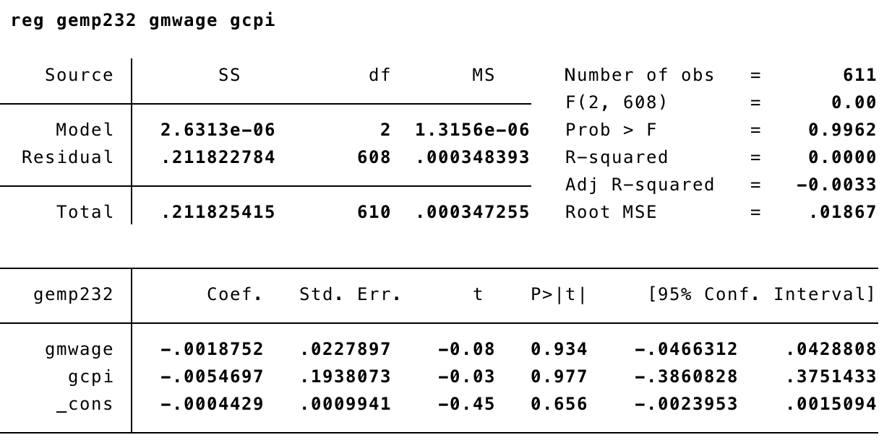

Answer: The estimated equation is:

gemp232 = −0.0004 − 0.0019gmwage − 0.0055gcpi

The coefficient on gmwage is puny with a very small t statistic. In fact, the R-squared is practically zero, which means neither gmwage nor gcpi has any effect on employment growth in sector 232.

(d) Add lags 1 through 12 to the employment growth equation. Does growth in minimum wage have a statistically significant effect on employment growth, either in the short run or long run? Explain.

Answer:

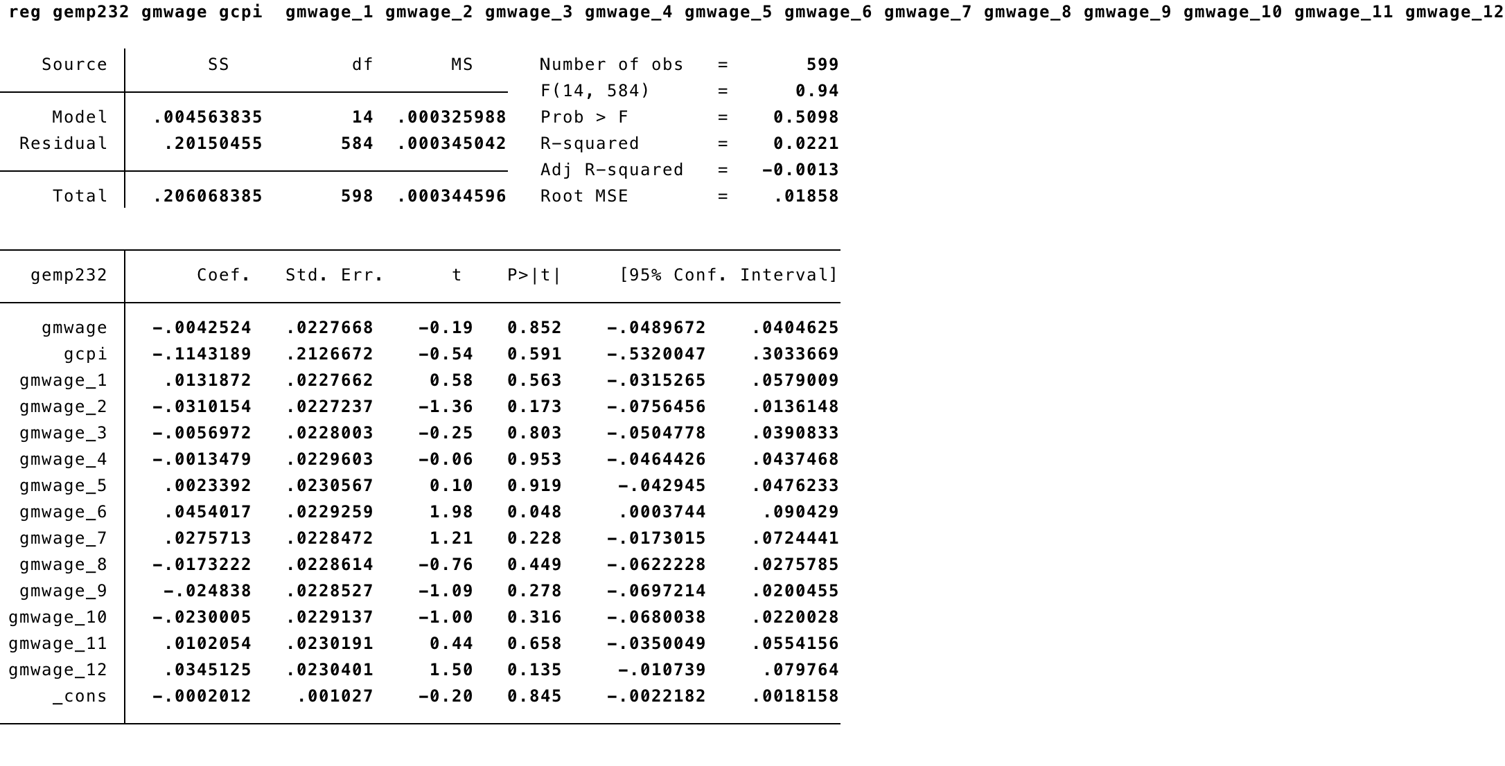

Adding lags of gmwage does not change the basic story. The F test of joint significance of gmwage and lags 1 through 12 of gmwage gives a F statistic of F = (.206036814−.20150455)/12 = 1.09, which is lower than the critical value. The coefficients .20150455/584 change sign and none is individually statistically significant at the 5% level. Therefore, there is little evidence that minimum wage growth affects employment growth in sector 232, either in the short run or the long run.

p-value = 0.3657